**Majors Division Rules (YAC & SOAC) rev. 3/25**

**THIS IS A LEAGUE OF GENTLEMEN** - TEAMS SHARE BASEBALLS - EACH TEAM PROVIDES TWO (2) NEW LEAGUE AUTHORIZED BALLS TO START - AWAY TEAM PROVIDES THE 5TH BALL - AND ALTERNATES WITH HOME TEAM IF NECESSARY.

**NO HECKLING OF PITCHERS WILL BE PERMITTED** - THE HITTING TEAM MAY CHEER FOR OWN TEAM, BUT THERE SHOULD BE NO OUTBURSTS WHEN THE PITCHER IS IN WINDUP.  SPORTSMANSHIP IS THE SPIRIT OF THE LEAGUE & THE RULE.

**BASEBALLS** – **Approved Game Balls**

Teams may use Cushioned Cork Baseballs - or other league cleared Cushioned Cork Baseballs.

Each Team shall provide at least 2 game balls for each game. After that, each team alternates - away team first....

No rubber pill, or solid cork baseballs... Please have "cushioned cork center" baseballs for safety and quality.

**Teams Play on 50'/70' Field.**

**Bats allowed** - wood, and certified USA and BBCOR.50 Bats.  Bat diameter will not exceed (2”5/8) (non-wood bats must have USA bat or BBCOR stamp or label)

**Regular Season Schedule - Rescheduling Games**

**Game time limit** –no new inning may start after 1:45 minutes.

**Game Schedules:** The Major league game schedule, as determined by the League Commissioner, will be strictly adhered to. Coaches will not be allowed to re-schedule games for any reason unless authorized by and handled by the League Commissioner.

**Postponements:** The League Commissioner will determine postponed games. If the fields are not playable, cancelled games will be posted via email or the YAC/SOAC website. Parents should check email prior to all games where the weather is questionable.

In the case of rainout – please contact the opposing coach, League Coordinator, and umpire. Make up games will be played at mutually agreed upon dates & Locations by both coaches. Rain - Games are considered official after 4 innings – (3 ½ if home team is ahead)

**FORECAST FOR RAIN – HOME TEAM MAKES THE CALL -**Most importantly - please contact opposing coaches and call umpires DIRECTLY. – Please make a call at least two hours before game time – if game is called after the umpire travels to the game – they are entitled one-half game fee or $40.

**THUNDER & LIGHTNING POLICY -**Thunder and lightning necessitates those games be suspended. The occurrence of thunder and/or lightning is not subject to interpretation or discussion ‐ thunder is thunder, lightning is lightning. With any weather in the forecast, please set up a plan for shelter prior to the start of a game.  When thunder is heard and/or when lightning is seen, the following procedures should be adhered to:

Suspend play and direct participants to go to shelter, a building normally occupied by the public or if a building is unavailable, participants should go inside a vehicle with a solid metal top (e.g., bus, van, car). Do not permit people to stand under or near a tree; and have all stay away from poles, antennas, towers, and underground watering systems. After thunder and/or lightning have left the area, **wait 30 minutes after the last boom is heard or strike is seen before resuming game.**

**GAME INCIDENTS**

Any conduct deemed detrimental to the game by the game umpire shall result in a game ejection or forfeiture.

If anyone associated with a team (coach or player) is ejected from a game, that person will have an automatic one (1) game suspension, for the following game, the first time. In the event the following game is not played due to inclement weather or schedule conflicts, the suspension applies to the next game played; The second time that same person is ejected, the league commissioner will review the matter for further disciplinary action. Game umpires will notify the appropriate league director of the suspended player's name and game conduct.

**There will be NO Protesting Games**

**Fielding** – All players must play at least 1 inning in the field.

**Teams missing players** –If a team shows up with only 8 players, they will play with 8 and they will not be penalized by having the 9th spot in the lineup considered an automatic out.  If a team has only 7 players (which is the Minimum needed to play an official game.) they will receive **one automatic out** after the last spot in the lineup comes to bat.  Example (If a team has only 7 players, they will receive 1 out after the 7th player bats.)

**Guest Players** – Can only be used if team has 8 or less players. Guest players will bat last and not be allowed to pitch. No guest players allowed in the playoffs

If both teams have 10 players and coaches agree, they can play with 4 outfielders.

**Offensive** – Teams will roster bat.

**5 Run Rule:** A half inning will end when the defensive team records 3 outs or when a team scores 5 runs. On the play that scores the 5th run in an inning, additional runs will be counted until that play is completed.  Example: 4 runs are already in for the inning and there are bases loaded.  A hit scores 3 runs; all 3 runs will count giving that team a total of 7 runs for the inning. **In the last inning, 3 outs are required, regardless of the number of runs scored.   When the umpire declares that an inning is the last inning due to reaching the no-new inning time (1:45), there will be unlimited batters in that inning until 3 outs are made.  However, if the visiting team was limited to 5 runs (before the time limit call), then the home team will also be limited to 5 runs.** Example (it is the top of the 5th inning, and the time is getting close to 1:45 since the start of the game, at some point in that part of the inning a Coach or Umpire should notify the other coach that due to the time limit, we are now in **THE LAST INNING OF THE GAME**.) If this was not realized until the bottom of the 5th inning and the away team was limited to the 5-run rule in their half of the inning, then the home team will be limited to the same 5 run rule as well.

**Mercy Rule** –A team trailing the leading team by 12 Runs after 4 FULL innings, (3 ½ with the home team ahead) shall concede defeat immediately. It would be drop dead after the 4th Inning – any time a team goes up by 12 runs the game will be considered over, no last licks needed after 4 innings.

**On Deck Batter (warm up):** On deck batter will **only be permitted if there is an enclosed designated area.** No open area, on deck batters.

**Substitutions:** Defensive player substitutions may be made freely throughout a game. However, once a pitcher has been removed from the game as a pitcher, **he may not re-enter the game as a pitcher.**

If a player is removed due to injury (and skipped in the lineup - that player MAY NOT RETURN TO THE GAME)

**PITCHING RULES – There will be a pitching limit of 4 innings or 70 pitches, whichever comes first. The 70 Pitch count will be a HARD STOP, meaning there is no exception for the pitcher to finish the batter. Each coach should track pitches for both teams.**

**If a Pitcher hits 3 batters in an inning or 4 in the game, he will be removed.**

**Balks** – No balks called in April, starting May 1st each pitcher gets 1 warning, Playoffs no Warnings. Fake to third – throw to first pickoff is allowed. No Balks called in the Fall Season.

* **Below is a Pitch smart chart for information only. This can help when dealing with pitcher who pitches for multiple teams.** 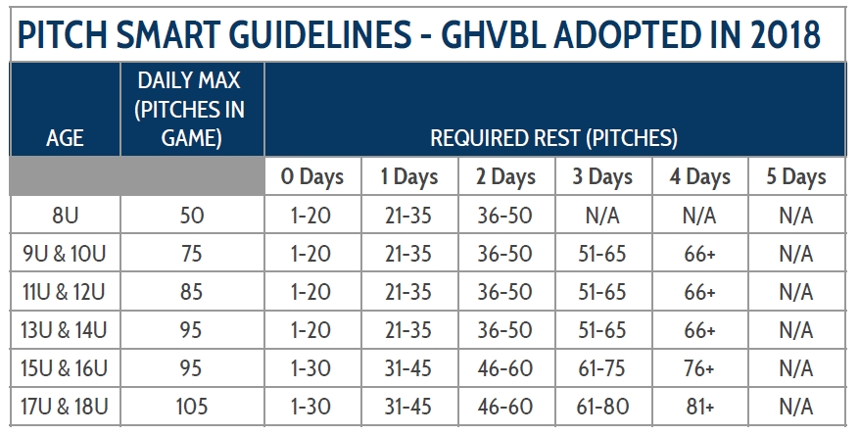

**Additional PLAYING RULES**

**Slap Bunt/Slashing. NOT ALLOWED** - Successfully batting a ball, after, in the umpire’s judgment, attempting to feint a bunt, shall be treated as an illegally batted ball. Runners return to their bases. The batter is out.

**STEALING BASES** - Full Leading & Stealing - **Headfirst sliding is ALLOWED**.  There is no limit to the number of steals, and stealing home is allowed.

The Ball is always considered live and in play, even after a batter walks. Players need to be aware that a runner can steal ANY TIME the game is in play.

**headfirst sliding is Allowed**

Courtesy Runners - are permitted ANYTIME - for Catcher and/or Pitcher OR INCOMING catcher and or Pitcher (not required). Runner must be last batted out.

**Dropped third strike is live ball** with no runner on first base or with two outs, the batter may then attempt to reach first base and must be tagged or thrown out. With two outs and the bases loaded, the catcher who fails to catch the third strike may, upon picking up the ball, step on home plate for a force-out or make a throw to any other fielder. **If at the time of the strike three pitch, first base is occupied with fewer than two outs, the batter is automatically out and cannot become a runner**. On a drop 3rd strike with the safety-first base, the fielder has the right to use the inside base.  Since it is for safety, we allow the fielder to use that base on drop 3rd strike only.

**EXTRA INNING RULES, TIME LIMITS, TIES**

**6 innings**. Regulation games called due to darkness, Time, or weather-related MAY end in a tie, during the regular season games. Playoff games will be played until there is a winner. California rule will begin in the 7th inning. Whereas the last out will start on 2nd base.

**CLEATS** - Plastic Molded (No Spikes) -

**CATCHER’S MASK, HELMET, AND THROAT PROTECTOR**– An extended “dangling” throat protector is considered a required part of the catcher’s mask. Hockey-style catcher’s masks with built-in extended throat protection are approved and do not require an extended “dangling” throat protector. The catcher’s mask shall not have a chrome or mirror-like surface.    The catcher’s helmet and mask combination shall meet the NOCSAE standard which includes having full ear protection with dual ear flaps.  The skull cap and mask combination does not meet the NOCSAE standard, nor does it provide full ear protection with dual ear flaps and is not permitted.

**DOUBLE BAG @ FIRST**

Games may be played with or without the double bag at first. If a field has a double base, all infield outs runner must touch the orange (outside) base and the first baseman must be in contact with the white part of the base when a play is being made. If there is a base hit the runner can touch either base.

**BLOCKING BASES OR PLATE**

Obstruction shall be called if a runner does not have access to the bag/plate. The runner could/will be awarded 1 base. A defensive player cannot block a base without the ball.

**BASERUNNING**

**Our League IS A SLIDE OR AVOID CONTACT LEAGUE** - Forceful, purposeful collisions are grounds for immediate ejection.  Players are not required to slide into all bases if they are avoiding contact. If a play is being made, the player may go in standing but must make the effort to avoid contact. If umpire deems contact unnecessary, the runner is out and if in the opinion of the umpire, it was intentional, the player will be ejected.

Infield Fly is in play.

**COACH TRIPS TO MOUND**

Coach may make two trips per inning (for each new pitcher).  At any time during the game, a pitcher receiving a 3rd visit from a coach MUST result in removal of the pitcher.

**Catching/Pitching Restrictions**

No restrictions on pitchers going to catch or catchers going to pitch.

**Playoffs (Single Elimination)**

All teams make the playoffs – Higher Seed will be the home team.

Seeding will be based on a point system for regular season games. 3 points for a Win, 2 for a tie and 1 for a loss.

No game time limit for playoffs.

Regular Season Tiebreaker for two teams at end of season will go first to head-to-head (HTH) record, then best runs against in (HTH) games if split. If teams did not play in regular season, then best runs against average (RAA) in regular full season, lowest (RAA) to highest (RAA).

3 (or more) Team Tiebreaker – (HTH) if 1 team has beaten all the other teams it tied. Then Teams seeded by best runs against average (RAA) in full regular season lowest (RAA) to highest (RAA)

If runs against average (RAA) is identical, league considers greatest strength of win, lastly strength of schedule.

Normally no Playoffs in the fall season.